Guapurium caipirinha (Myrtaceae), a new species of jaboticaba from Brazil with pentamerous flowers

JOÃO MARCELO ALVARENGA BRAGA¹*, EUGENIO ARANTES DE MELO², HÉLIO CAIXETA TIBÚRCIO³, ADELÍCIO PEREIRA DA SILVA⁴, RODRIGO BORGES PEREIRA⁵, MARCO TÚLIO CÔRTES DE LACERDA⁶ & HARRI LORENZI⁷

¹Instituto de Pesquisas Jardim Botânico do Rio de Janeiro, Rua Pacheco Leão, 915, 22460-030, Rio de Janeiro, RJ, Brazil. https://orcid.org/0000-0002-6124-1970
²Independent researcher, Rua Joseph Mendel 41, 25250–597, Ipatinga, MG, Brazil. https://orcid.org/0009-0000-4075-4868
³Independent researcher, MG, Brazil. https://orcid.org
⁴Independent researcher, MG, Brazil. https://orcid.org
⁵Independent researcher, MG, Brazil. https://orcid.org
⁶Coleção Botânica Sítio E-jardim, Estr. do Aviário s.n., 25250–597, Xerém, Duque de Caxias, RJ, Brazil. https://orcid.org/0000-0002-7862-1734
⁷Jardim Botânico Plantarum, Av. Brasil, 2000, 13380-410, Jardim Marajoara, Nova Odessa, SP, Brazil, https://orcid.org
*Corresponding author: jmabraga@jbrj.gov.br

Abstract
Guapurium caipirinha (Myrtaceae) is a new species of jaboticaba from Minas Gerais state, Southeastern Brazil, which morphologically resembles Plinia oblongata, from which it differs in being a shrub or treelet 1–3 m height, with exclusively pentamerous flowers, and membranaceous fruit peel with very sweet pulp. Detailed morphological description, etymology and vernacular names, information on history, phenology, conservation, habitat and taxonomic notes, distribution map, and images of living plant and type specimen are provided.

Keywords: cultivated plants, ‘jabuticaba’, Myrteae, Plinia, Pliniinae

Introduction
Plinia s.l. Plumier ex Linnaeus (1753: 516) is a Myrtaceae genus currently composed of 81 species (POWO 2024), of which 43 occur in Brazil (Flora e Funga do Brasil 2024). Its morphological limits have been historically discussed, but its taxonomy remains unstable (Barrie 2004). However, this genus is circumscribed through the combination of morphological features, being delimited by the inflorescences glomerate or racemiform, rarely paniculiform, flowers tetramerous with calyces persisting after anthesis, ovaries with two locules, each with two ovules, and seeds with two distinct plano-convex cotyledons with inconspicuous hypocotyl (Sobral et al. 2017).
Some species of Plinia with cauliflorous inflorescence, racemiform or with flowers almost sessile and glomerate, which previously belonged to the genus Guapurium Jussieu (1789: 324), are quite remarkable due to their edible, globose, relatively large fruits up to 45 mm in diameter, with membranaceous or coriaceous peel, containing a delicious, juicy pulp. These species are worldwide known as jaboticaba (‘iapoti'kaba’ in Tupi-Guarani indigenous linguistic branch or ‘jabuticaba’ in Portuguese). The jaboticaba was one of the main native fruits to attract the attention of the first Portuguese settlers in the 16th century. Fernão Cardim (1548-1625) wrote that it was already long appreciated and cultivated by the indigenous populations that inhabited Brazil, being eaten fresh or processed into wines (Cardim 1925). Vellozo (1829), in his field expeditions at the end of the 18th century, already reported that jaboticaba species were cultivated and their tasty fruits were sold in the Brazilian state of São Paulo. Spix & Martius (1823), in the following century, also made similar observations, indicating the occurrence of jaboticaba in the states of Minas Gerais, Rio de Janeiro and São Paulo. In the current scenario, jaboticaba species are widely cultivated around the tropical and subtropical world, and in Brazil they are usually sold on a local scale (Lorenzi et al. 2006, 2015; Wagner Júnior et al. 2022). The jaboticaba species have been first associated to the genus Guapurium (Jussieu 1789), later to Myrtus (Martius in Spix & Martius 1823; Vellozo 1829), then transferred to Myrciaria (Berg 1857), included in Eugenia (Kiaerskou 1893), back to Myrciaria (Mattos 1962, 1970, 1976, 1983) or treated as Plinia since (Kausel 1956; Sobral 1994; Mattos 1998). In conclusion, Stadnik (2020) used his molecular studies for detailing the kinship relationships and morphological delimitations between Guapurium and Plinia, considering them independent genera.
Starting in 1990, a series of field expeditions through Brazil have been led by one of the authors (HL) and later organized by Jardim Botânico Plantarum, aiming to collect samples for the herbarium HPL as well as to get propagating material of some Myrtaceae species in habitat and among cultivators. These field expeditions intended to delimit the natural distribution of the jaboticaba species described by Mattos (1970), some to that day with unknown provenance. In 2007, an expedition to the central region of Minas Gerais state revealed the existence of large natural populations of a jaboticaba locally known as ‘caipirinha’. This species is promptly recognized in its habitat for being a shrub to treelet, with a dense canopy, generally semi-circular and semi-spherical in shape, with its branches touching the ground, and preventing from seeing its multiple trunks, or forming a tortuous main trunk, with many lateral branches and shoots starting from the ground. Its fruits are highly prized by local inhabitants, of which in a certain way prevents the suppression of its individuals, including keeping them in pasture areas and backyards. Later, Lorenzi et al. (2015) published colour photos of this species, showing the flowering branches and fruits, along with a brief description of its main features, and also remarking that it was an undescribed species. This hypothesis has been continuously investigated since them, of which ultimately allowed us to confirm that it is indeed a new species, especially since we observed that its flowers are pentamerous. This floral feature is unknown for almost all genera of subtribe Pliniinae E.Lucas & T.Vasc. (in Lucas et al. 2019: 566), except Algrizea Proença & NicLugh. (in Proença et al. 2006: 320), which also has pentamerous flowers. Finally, agreeing with Stadnik's proposal (see Stadnik 2020), we thus describe this new species in Guapurium.

Material and methods
Morphological studies were based on specimens deposited at HDJF, HPL, HUFSJ, R, RB and UB, and on the observation of living plants in their habitat and under cultivation. Digital images of specimens available at REFLORA (https://reflora.jbrj.gov.br/), CRIA (https://specieslink.net/), and JSTOR Global Plants (http://plants.jstor.org/) were also analysed. Morphology terminology followed Hickey (1973), Briggs & Johnson (1979), Hewson (1988), Radford (1986), and Beentje (2016). Morphological descriptions were based on dried material, except the fruits and general information on habit, flavour and colouring. The parameters extent of occurrence (EOO) and area of occupancy (AOO) were calculated using the Geospatial Conservation Assessment Tool (GeoCAT Platform) (http://geocat.kew.org). Geographical distribution map was built through by QGIS version 3.34 (https://qgis.org).

Taxonomy

Guapurium caipirinha J.M.A.Braga, M.T.C.Lacerda & Lorenzi, sp. nov. (Figures 1–5)
Type:—BRAZIL. Minas Gerais, Serro, Fazenda na margem da rodovia Serro e Santo Antônio do Itambé, próximo a Serro, pasto, 18°34'17"S, 43°20'39"W, 802 m alt., 11 October 2016, fl., J.F.Q. Faria & T.J.O. Otoni 6676 (holotype RB; isotypes: HDJF, HUFSJ, UB).

Diagnosis:—Guapurium caipirinha differs from all other jaboticaba species through its consistently pentamerous flowers. It differs of Plinia oblongata in being a shrub or treelet up to 3 m height (vs. tree up to 12 m height), with 5-petals (vs. 4-petals), and membranaceous fruit peel with very sweet pulp (vs. coriaceous peel with sour flavor and bitter aftertaste pulp).

Description:—Shrubs to treelets 1–3 m height, usually with multiple trunks, tortuous, usually quite branched since the base; canopy to 3–6 m in diameter, dense, semi-circular and semi-spherical, branches arched and touching the ground, or sometimes single trunk, with branches directed upwards and misshapen canopy. Trunk smooth or slightly rough (when young), exfoliating, externally bark dark-brown or reddish-brown, exposing a brown or greyish internal bark. Young twigs cylindrical to lightly flattened, sometimes irregularly striated, green or brownish, puberulous to pubescents, the trichomes ca. 0.1 mm long, whitish or brownish; cataphylls 0.5–4 × 0.5–1.5 mm, lanceolate to ensiform, apex acute to acuminate, conduplicate, green or brownish, puberulous to pubescents, ciliate, the trichomes ca. 0.1 mm long, whitish or brownish. Leaves dark green, or reddish to brownish when young; petioles 0.1–0.3 cm long, green, cylindrical, puberulous to pubescents; blades (1–)1.8–4.1 × 0.6–2.1 cm, chartaceous, wide-elliptic, base rounded, apex acute to attenuate, or sometimes with caudate or cuspidate appearance when dry, mucronulate, mucron green to blackish, sometimes lacerated; surfaces essentially glabrous, or puberulous to pubescents in base of the midvein on both sides; midvein slightly raised, glabrescent to puberulous, the trichomes ca. 0.1 mm long, whitish in adaxial surface, strongly raised, glabrous or glabrescent on the abaxial surface; marginal veins 2–3, formed by the basal pairs of secondary ramifications, resulting in a brochidodromous pattern, the inner one 1.8–2.5 mm, the middle one 0.6–1 mm, and the outer one 0.2–0.5 mm from the margin or indistinguishable; margins slightly involute, ciliate to glabrescent, the trichomes ca. 0.1 mm long, whitish; glands on both surfaces conspicuous, blackened, or hyaline when fresh, up to 0.1 mm in diameter. Inflorescences cauliflorous on the main trunk and thinner branches, with up to ten flowers densely crowded in fascicles racemiform; rachis 5-11 mm long, pubescent to hirtellous, the trichomes ca. 0.1 mm long, whitish-hyaline; paleo-green to brownish; bracts 0.8–1.5 × 1–1.2 mm, orbicular to lanceolate, apex obtuse to acute, conduplicate, pubescent to hirtellous, the trichomes ca. 0.1 mm long, whitish-hyaline; bracteoles 0.8–1.5 × ca. 0.8 mm, orbicular to lanceolate, apex obtuse to acute, cymbiform, hirtellous, the trichomes ca. 0.1 mm long; pedicels 3–6.5 mm long, pubescent to hirtellous, the trichomes ca. 0.1 mm long, whitish-hyaline. Flowers externally densely glandulose, glabrous or sparsely covered with trichomes up to 0.5 mm long, whitish-hyaline; floral disk ca. 2 mm in diameter; sepals 5, 0.5–1 × 0.7–1 mm, lobes ovate, apex rounded, reflexed after anthesis, membranaceous, green, glabrous to puberulous, sparsely ciliate, the trichomes ca. 0.1 mm long, whitish-hyaline, hypanthial cup 1–1.2 mm deep, glabrous to puberulous; petals 5, 2–3.2 × 2–4.2 mm, orbicular to obovate, concave, apex rounded, reflexed after anthesis, membranaceous, white, externally sericeous, internally glabrous, margin ciliate, the trichomes 0.1–0.2 mm long, whitish-hyaline; staminal ring pentagonal or nearly so, 0.2–0.4 mm thick, sparsely covered with trichomes ca. 0.2 mm long, whitish, filaments 3.8–4.2 mm long, anthers ca. 0.5 × 0.3 mm, oblong, with a visible septum, apical gland not seen; ovary 2-locular, locules 2-ovulates, glabrous, style 3.5–4.5 mm long, glabrous, stigma punctiform, minutely papillose. Fruits 9–25 mm in diameter, glabrous, peel thin, membranaceous, smooth, green (immature) to dark purple or black (mature), apex sometimes crowned by a 5-arm greenish or purplish asterisk, pulp white, juicy, sweet; seeds 1–2, ellipsoid, 5.8–6 × 4.5–5 mm, brownish, cotyledons free, plano-convex, with no visible hypocotyl, with short hairs and pulp strongly adhered to the testa.

Distribution, habitat and conservation notes:—The fruits of Guapurium caipirinha are very sweet and appreciated by local residents, that consume them out of hand or use them for preparing sweets from their peel. Maybe that is the reason why it is often preserved in backyards of rural properties, and also commonly observed in pasture fields and forest edges of the cities in Vale do Rio Doce, such as Belo Oriente, Ipatinga and Santana do Paraiso. In these cities, the species is known as ‘caipirinha’. In the interior of Seasonal Semideciduous Forest, an increasingly fragmented and destroyed environment throughout the state of Minas Gerais, the species is a bit harder to find, as it usually presents a nearly upright canopy that confuses it with other native species. In the Vale do Jequitinhonha it is known as ‘birrinha’, and where larger individuals with a more upright crown are found, reaching up to 3 m height. It is also usual to find severely pruned individuals, what easy accessing and harvesting of the fruits. In the region between Serro and Diamantina cities there are large populations of Plinia caipirinha, with smaller individuals, some up to 1 m height, occurring especially in rocky outcrops and roadside long (Edilson Giacon, pers. com).

Phenology:—It flowers and fruits from July to October, according to the rainy season. In cultivation, it can flower and bear fruit more than once a year, especially during periods of prolonged rain after drought.

Taxonomic notes:—Although scarcely collected for scientific purposes, Guapurium caipirinha has been cultivated since 2007 by Brazilian rare fruit growers. Two of the authors of the current study first published information and photos about this species (see Lacerda 2008; Melo 2009). Shortly after, Lacerda (2010) added new information on its natural distribution and habitat, even as its appropriation for use in bonsaism. Since then, it became widespread among Brazilian bonsaists, due to its very small leaves that give the desired appearance of dwarfism. Fruit flavour is deliciously sweet, different from the typical sour pulp of Plinia oblongata (Mattos) Mattos (1998: 5). This jaboticaba species described by Mattos (1970, 1976, 1998) is locally known by the vernacular names ‘jabuticaba-ponhema’, ‘jabuticaba-ácida’, ‘jabuticaba-amarga’, ‘jabuticaba-amargosa’, ‘jabuticaba-azeda’ and ‘jabuticaba-jiló’. Most of these names refer to the sour flavour of pulp and fruit peel with resinous-bitter aftertaste. Guapurium caipirinha is also morphological differentiated from Plinia oblongata by the smaller tree size (shrubs to treelets up to 3 m vs. trees reaching up to 12 m), number of sepals and petals (pentamerous vs tetramerous or rare with 5 sepals), and fruits with thinner peel thickness (membranaceous vs coriaceous). Among fruit growers, Plinia oblongata is well-known by its very large fruits when compared to most jaboticaba species (except P. coronata (Mattos) Mattos [1998: 5] with up to 45 mm in diameter), as its fruits reach up to 40 mm in diameter, while in Guapirium caipirinha they present a maximum up to 25 mm in diameter.
Living plants of Guapurium caipirinha can be seen on following videos of YouTube platform: ‘Sítio E-jardim’ (https://www.youtube.com/watch?v=erwxJsxb_Fc), ‘ABC do Bonsai’ (https://www.youtube.com/watch?v=1tfdWKWjo90; https://www.youtube.com/watch?v=a5W5964Sw4c), ‘Ciências e Tecnologias’ (https://www.youtube.com/watch?v=ObWakL7NUF4), and ‘Frutas Raras’ (https://www.youtube.com/watch?v=1f2Z3v8Zjg8).

Etymology:—The vernacular name ‘caipirinha’ is the diminutive of ‘caipira’, a Brazilian word originated from Tupi-Guarani indigenous language branch meaning from the bush or simply wild (caa = bush, jungle + ipura = from inside). In Brazil, traditional people living in small rural properties, usually far from urban areas, with a simple life and rustic habits, are also called ‘caipira’ (bumpkin in English).

Paratypes:—BRAZIL. Minas Gerais: Belo Oriente, macroregião do Vale do Rio Doce, Brauninha, Sítio Goiabal, propriedade de José Carneiro, 19°16'25"S 42°27'45"W, 251 m alt., 25 July 2023, fl. buds, J.M.A. Braga et al. 23-050 (RB); ibid., 19°16'25.2"S 42°27'43.7"W, 8 August 2023, fl., E.A. de Mello & J. Carneiro s.n. (RB); ibid., 6 Sep. 2023, fr., 19°16'25.2"S 42°27'43.7"W, E.A. de Mello & J. Carneiro s.n. (RB). Felício dos Santos, macroregião do Vale do Jequitinhonha, estrada para Loronha, Lajeado e Canela, localidade Fábrica, propriedade de Vicente de Paula Siqueira, solo de Cerrado, tipo latossolo, 18°05'26,10"S 43°15'57,30"W, 6 September 2023, fl., H.C. Tibúrcio & A.P. da Silva s.n. (R, RB, HPL); Felício dos Santos, Vale do Jequitinhonha, localidade das Loronhas, propriedade de Dico, 18°06'38,10"S 43°16'20,00"W, fl, 6 September 2023, fl., H.C. Tibúrcio & A.P. da Silva s.n. (RB). Ipatinga, Ipaneminha, Sítio Nelson Ferreira, 19°24'10"S 42°38'27"W, 8 August 2023, fl., E.A. de Mello s.n. (RB); ibid., 6 September 2023, fr. [young], E.A. de Mello s.n. (RB); Ipatinga, Ipanemão, APA Ipanema, Estrada Ipanemão, próximo da Pousada Canto da Mata, 19°25'18"S 42°39'21"W, 546 m alt., 26 July 2023, fl. buds, J.M.A. Braga et al. 23-051 (RB); Ipatinga, Barra Alegre, Ipaneminha, Estrada Ipaneminha, proximidades da Pousada e Pesque e Pague Mané, 19°24'12"S 42°38'27"W, 618 m alt., 26 July 2023, fl. buds, J.M.A. Braga et al. 23-054 (RB). Santana do Paraíso, Achado, Fazenda do Lauro, 19°21'06"S 42°37'00"W, 707 m alt., 26 July 2023, fl. buds, J.M.A. Braga et al. 23-058 (RB). Cultivated: Rio de Janeiro, Duque de Caxias, Xerém, Coleção Botânica Sítio E-jardim [ramos coletados para enxertia em 30/01/2007 no Médio Vale do Rio Doce, Achado, Santana do Paraíso, MG e muda plantada definitivamente em 2009 – Nº acesso SEJ: A4], 27 August 2021, fl., M.T.C.de Lacerda et al. s.n. (RB); ibid., 24 September 2021, fr., M.T.C.de Lacerda & J.M.A. Braga s.n. (RB).

Acknowledgements
The authors thank Thiago Fernandes for his collaboration in all stages of this study, Aline Stadnik for the explanations on the reestablishment of the genus Guapurium, Marcos Sobral and Marcelo da Costa Souza for the discussion on Plinia species, and Jair Faria and Rosana Moreno Sena for the information on the types of Guapurium caipirinha and Plinia. oblongata, respectively. We also thank José Carneiro, Edilson Giacon, Gustavo Giacon, Arthur Dempsey and Walisson Santos for their help with fieldwork and with the discussion of jaboticaba species. Finally, we thank anonymous referees for their helpful comments and suggestions.

References
Barrie, F.R. (2004) Synopsis of Plinia (Myrtaceae) in Mesoamerica. Novon 14(4): 380–400.
Beentje H. (2016) The Kew Plant Glossary – an illustrated dictionary of plant terms. 2nd ed. Royal Botanic Gardens, Kew, 184 pp.
Berg, O. (1857) Myrtaceae. In: Martius, C. F. P. von (Ed.), Flora Brasiliensis. v. 14, par. 1. Frid. Fleischer in Comm., Lipsiae [Leipzig] & Monachii [Munich], pp. 1–468. https://doi.org/10.5962/bhl.title.454
Briggs, B.G. & Johnson, L.A.S. (1979) Evolution in the Myrtaceae - Evidence from inflorescence structure. Proceedings of the Linnean Society of New South Wales 102(4): 157–256.
Cardim, F. (1925) Tratados da terra e gente do Brasil. J. Leite & Cia., Rio de Janeiro, 434 pp.
Flora e Funga do Brasil (2024) Myrtaceae In: Flora e Funga do Brasil. Jardim Botânico do Rio de Janeiro. Available from: <https://floradobrasil.jbrj.gov.br/FB171> (accessed 25 January 2024).
Hewson, H.J. (1988) Plant Indumentum, a handbook of terminology. Australian Flora and Fauna Series n. 9. Australian Government Publishing Service, Canberra, 27 pp.
Hickey, L.J. (1973) Classification of the architecture of Dicotyledonous leaves. American Journal of Botany 60(1): 17–33. https://doi.org/10.1002/j.1537-2197.1973.tb10192.x
Jussieu, A.L. de (1789) Genera plantarum :secundum ordines naturales disposita, juxta methodum in Horto regio parisiensi exaratam, anno M.DCC.LXXIV. Herissant Typographum, Parisiis [Paris], 498 pp. https://doi.org/10.5962/bhl.title.284
Kausel, E. (1956) Beitrag zur systematik der Myrtaceen. Arkiv för Botanik 2(3): 491–516.
Kiaerskou, H. (1893) Enumeratio myrtacearum brasiliensium quas collegiunt Glaziou, Lund, Mendonça, Raben, Reinhardt, Schenck, Warming alique. In: Warming, E. (Ed.) Symbolarum ad floram Brasiliae Centralis cognoscendam. v. 39. Ex Officina Hoffensbergiana, Hauniae [Copenhagen], pp. 1–199. https://doi.org/10.5962/bhl.title.4459
Lacerda, M.T.C. de (2008) Plinia sp. nv. / jabuticaba-capirinha ou jabuticaba-de-bonsai. In: E-jardim.com. Mudas de plantas frutíferas. Available from: https://e-jardim.com/produto_completo.asp?IDProduto=335 (accessed 29 January 2024).
Lacerda, M.T.C. de (2010) Jabuticabeira-caipirinha, campeã dos bonsais. In: Blog do E-jardim. Available from: http://e-jardim.blogspot.com/2010/02/jabuticabeira-caipirinha-campea-dos.html (accessed 29 January 2024).
Linnaeus, C. (1753) Species plantarum exhibentes plantas rite cognitas ad genera relatas, cum diferentiis specificis, nominibus trivialibus, synonymis selectis, locis natalibus, secundum systema sexuale digestas. v. 1 Imprensis Laurentii Salvii, Holmiae [Stockholm], 560 pp. https://doi.org/10.5962/bhl.title.37656
Lorenzi, H., Bacher, L.B., Lacerda, M.T.C. de & Sartori, S. (2006) Frutas brasileiras e exóticas cultivadas (de consumo in natura). Instituto Plantarum de Estudos da Flora, Nova Odessa, 640 pp.
Lorenzi, H., Lacerda, M.T.C. de & Bacher, L.B. (2015) Frutas no Brasil nativas e exóticas (de consumo in natura). Instituto Plantarum de Estudos da Flora, Nova Odessa, 768 pp.
Lucas, E.J., Holst, B., Sobral, M., Mazine, F.F., Nic Lughadha, E.M., Proença, C.E.B., Costa, I.R. da & Vasconcelos, T.N.C. (2019) A new subtribal classification of Tribe Myrteae (Myrtaceae). Systematic Botany 44(3): 560–569. https://doi.org/10.1600/036364419X15620113920608
Mattos, J.R. (1962) Nota sobre Eugenia phytrantha Kiaerskou. Arquivos de Botanica do Estado de Sao Paulo 3(5): 293.
Matos, J.R. (1970) As espécies da secção Cauliflorae Berg do gênero Myrciaria Berg (Myrtaceae). Loefgrenia 51: 5–59.
Mattos, J.R. (1976) Espécies novas da secção Cauliflorae Berg de Myrciaria Berg (Myrtaceae). Loefgrenia 51: 1–10.
Mattos, J.R. (1983) Jaboticabeiras. Instituto de Pesquisas de Recursos Naturais Renováveis “AP” [Publicação IPRNR v. 10], Porto Alegre, 76 pp.
Mattos, J.R. (1998) Novidades taxonômicas em Myrtaceae – XV. Loefgrenia 112: 1–9.
Mello, E.A. de (2009) Jabuticaba caipirinha - Myrciaria jaboticaba In: Árvores do Brasil. Informações e estudos sobre árvores nativas brasileiras. Available from: https://www.arvores.brasil.nom.br/new/jabuticaipirinha/index.htm (accessed 29 January 2024).
POWO (2024). Myrtaceae In: Plants of the world online. Facilitated by the Royal Botanic Gardens, Kew. Available from: http://www.plantsoftheworldonline.org/ (accessed 25 January 2024).
Proença, C.E.B., Nic Lughadha, E.M., Lucas, E.J. & Woodgyer, E.M. (2006) Algrizea (Myrteae, Myrtaceae): a new genus from the highlands of Brazil. Systematic Botany 31(2): 320–326. https://doi.org/10.1600/036364406777585874
Radford, A.E. (1986) Fundamentals of plant systematics. Harper & Row, New York, 498 pp.
Sobral, M. (1994) Duas espécies e seis combinações novas em Plinia (Myrtaceae) do Brasil. Hoehnea 21(1/2): 199–205.
Sobral, M., Mazine, F.F. & Souza, M. da C. (2017) Three combinations in Brazilian Plinia (Myrtaceae). Phytotaxa 316(1): 88–90. https://doi.org/10.11646/phytotaxa.316.1.9
Spix, J.B. von & Martius C.F.P. von (1823) Reise in Brasilien auf Befehl Sr. Majestät Maximilian Joseph I., Königs von Baiern, in den Jahren 1817 bis 1820 gemacht und beschrieben. v.1. M. Lindauer, München [Munich], 412 pp. https://doi.org/10.5962/bhl.title.16406
Stadnik, A.M.S. (2020) Estudos Sistemáticos na subtribo Pliniinae E.Lucas & T.Vasc. (Myrtaceae). PhD thesis, Universidade Estadual de Feira de Santana, Feira de Santana, 135 pp.
Vellozo, J.M.C. (1829 [1825]) Florae fluminensis. ex Typographia Nationali. Flumine Januario [Rio de Janeiro], 352 pp. http://dx.doi.org/10.5962/bhl.title.745
Wagner Júnior, A.; Danner, M.A. & Citadin, I. (2022) Jabuticabeiras. Universidade Tecnológica Fderal do Paraná, Curitiba. 452 pp.

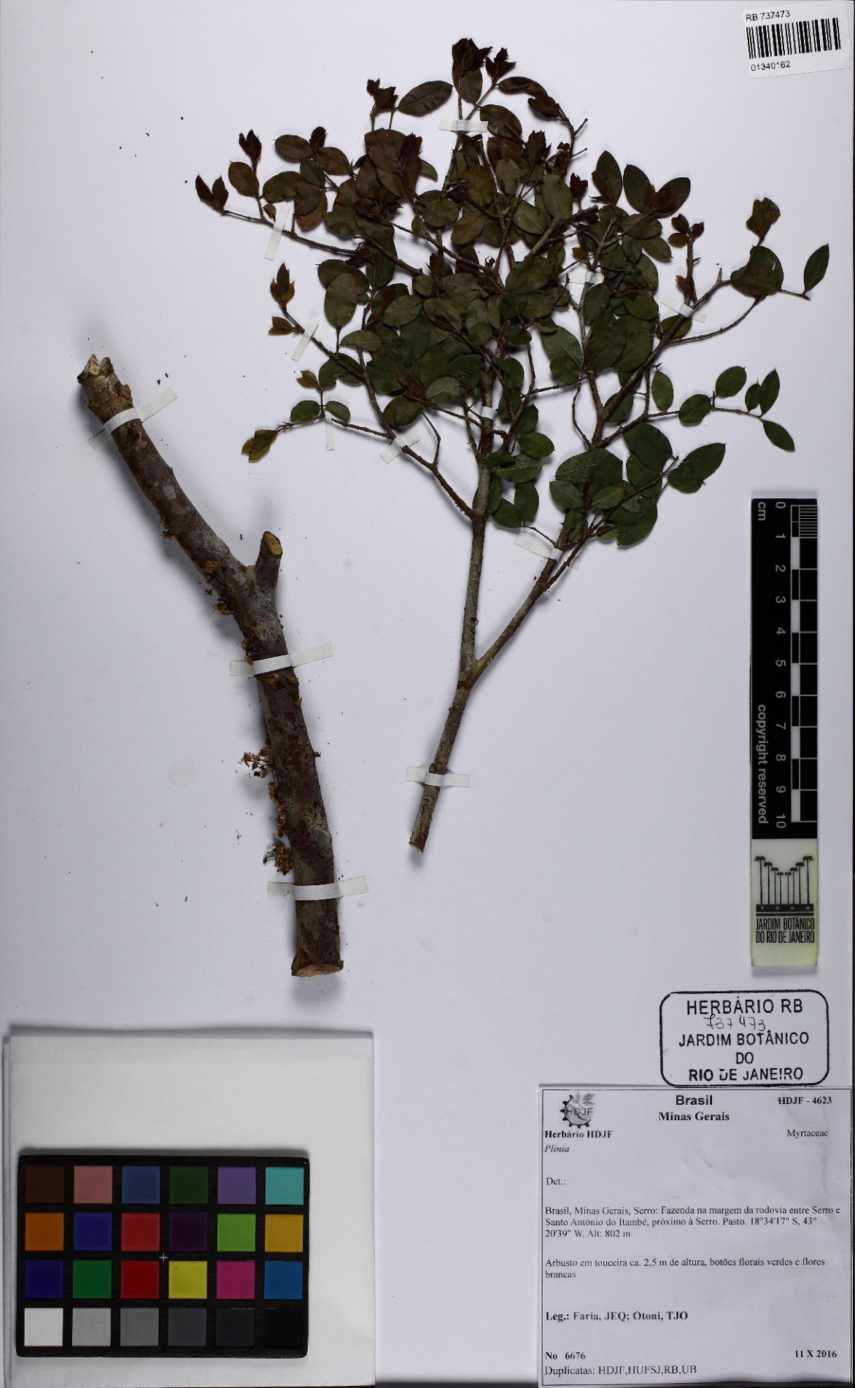
Figure 1. Holotype of Guapurium caipirinha (Faria & Otoni 6676, RB). Image reproduced with the consent of RB herbarium.
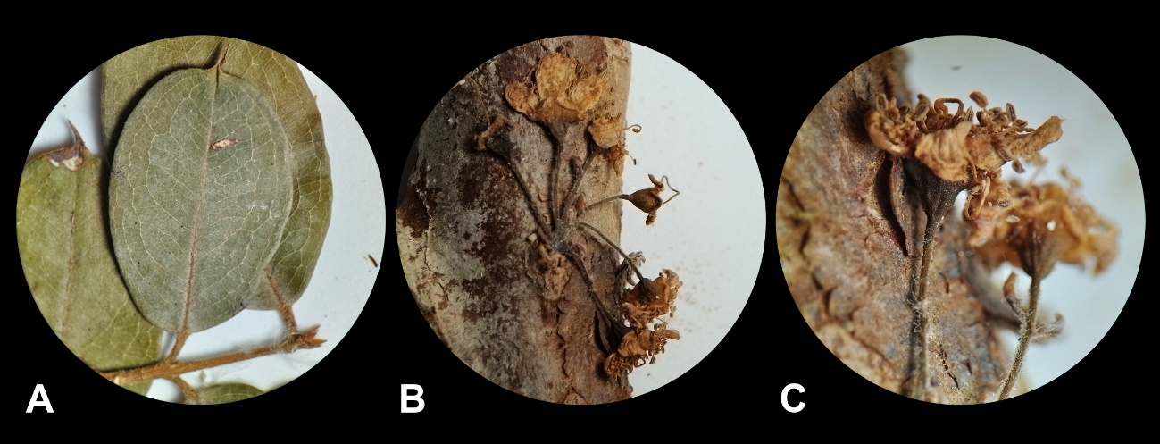
Figure 2. Guapurium caipirinha in dry state. A. Leaf. B. Cauliflorous inflorescence. C. Flowers. All from the holotype (Faria & Otoni 6676, RB).

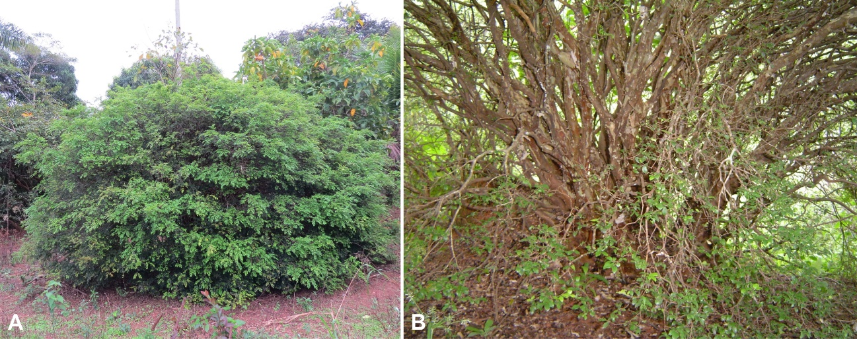
Figure 3. Living plants of Guapurium caipirinha. A. Habit . (B) Trunks (B) of Guapurium caipirinha. Photos: Eugenio A. de Melo.
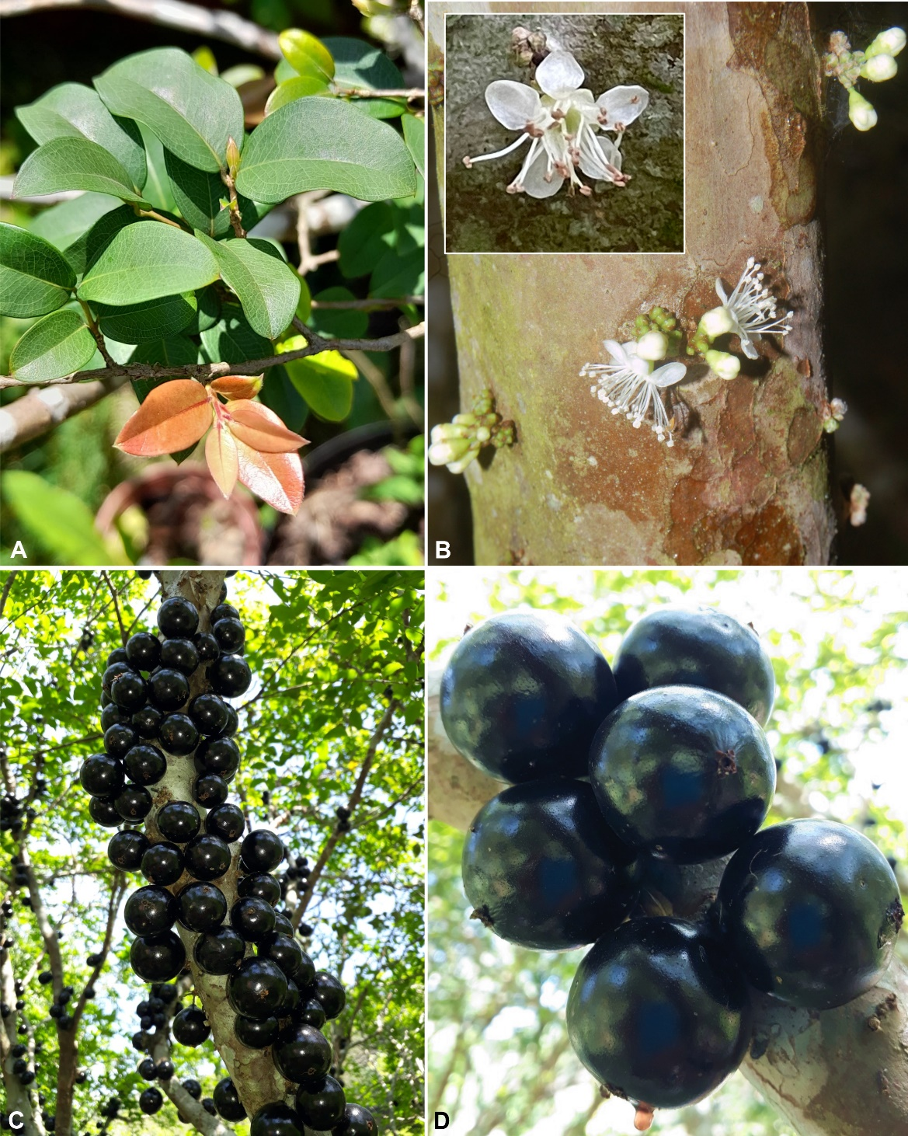
Figure 4. Living plants of Guapurium caipirinha. A. Leaves. B. Cauliflorous inflorescences with flower buds and open flowers. C. Trunk with fruits. D. Ripe fruits. Photos: A, C and D by João Marcelo Alvarenga Braga. B by Eugenio A. de Melo.

